**Fog App**

Purpose: An App that can help users navigate in foggy weather

Services that will be essential for development:

* Google Maps
* Gps

Flow:

**Phase 1: (Subject to change)**

* User registers account and complies to location usage

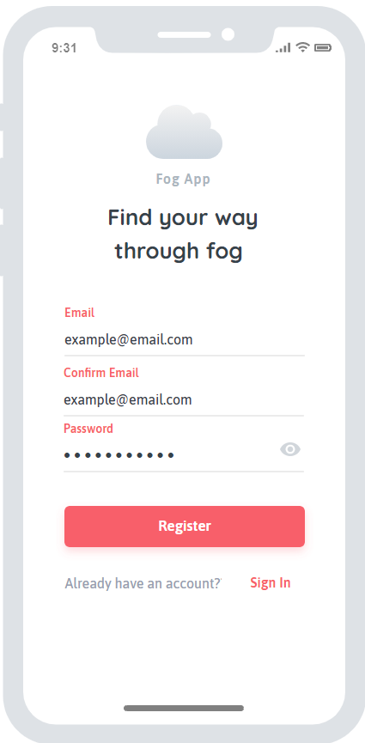

* User is taken to google maps screen where they can see nearby cars

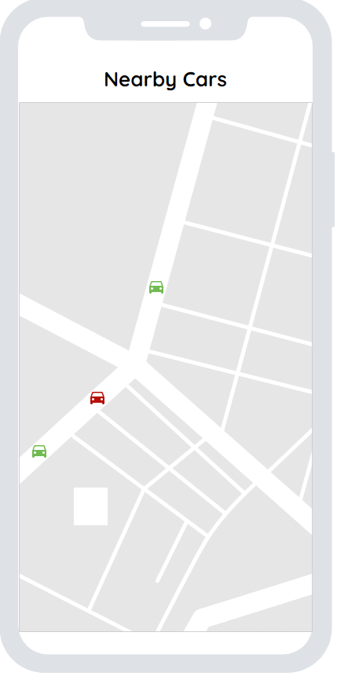

**Phase 2: (Subject to change)**

* User can follow any other car by tapping on the car icon
* User will be able to see a navigation line leading to the other car